**Chief Investment Officer of Freetrans Africa Inc. paid visit to the Minister’s Office**

"Sierra Leone is an epitome of stability and home to people of quality''

...Says Simon P. Saverys, Chief Investment Officer of Freetrans Africa INC  
Chief Investment Officer, Freetrans Africa INC, Simon P. Saverys, has stated that Sierra Leone is an epitome of stability and home to people of quality.

Saverys was speaking in a meeting held with the Minister of Transport and Aviation on Monday, 10th June, 2019, on the numerous investment opportunities in the transport and aviation sector in Sierra Leone.

He stated that he became interested in Sierra Leone after listening and interacting with His Excellency President Julius Maada Bio on a trip in Brussels, where he spoke on the steady transformative path that the country is on and how significant revenue is needed for the actualization of sector's plans.

He said their company is focused on early stage African investment opportunities and a networking of Africa´s most promising ventures with the right growth capital, which is why Sierra Leone has been selected as one of two countries in West Africa that fits this specific criteria for investment from several companies in significant sectors such as transport and aviation, trade and industry, health and more.

According to Saverys, his trip and stay in Sierra Leone since April this year, has reinforced his presuppositions of a country accommodating to authentic business ventures.

He concluded that they have selected a group of Sierra Leonean entrepreneurs from different businesses to partake in a dialogue and showcasing conference in July this year, aiming at facilitating investments in Sierra Leone.

Minister of Transport and Aviation, Kabineh Kallon, expressed his determination towards the uplifting of the transport and aviation sector before the end of their first term.   
This, he believes, will demonstrate to Sierra Leoneans that there is an ease of mobility, with the right plans, established infrastructure and facilities in a corrupt free nation.

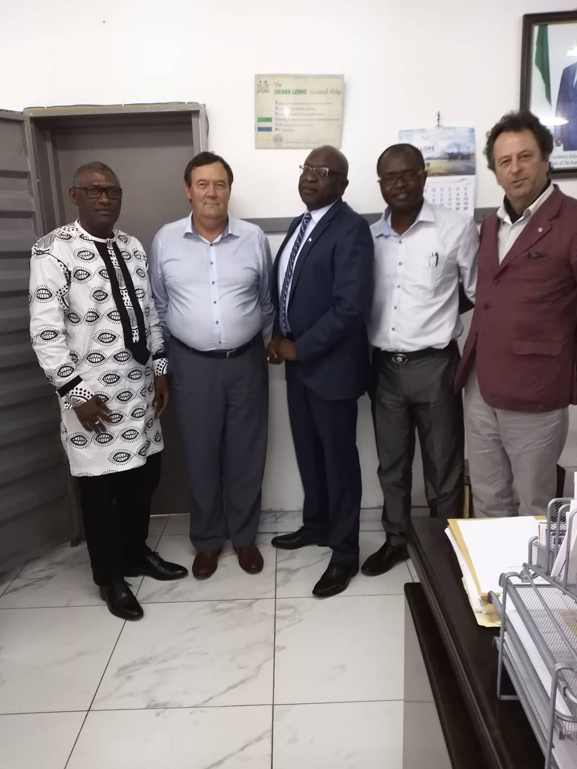Minister Kallon recommended the possibility of a regionalized flight system to be introduced among the three countries-Guinea, Liberia and Sierra Leone, adding that it will significantly reduce time spent on traveling for citizens who might want to avoid time consuming trips.

